**Auto Drone**

**Abstract**

The project is aimed at designing a common architecture in terms of hardware and software for an automated drone. On a high level, the system is divided into two parts, a communication layer and the subsystem layer. For every feature (or) operation, a separate subsystem is designed and attached with the main controller. The main controller receives all the inputs from various subsystems and makes driving decision based on those inputs. The output of main controller is just four PWM signal each of which operates Elevator, Aileron, Rudder and Throttle. This signals simulate the basic remote control so that the basic operations are not made complex. In this project, the following subsystems are planned, automated driving subsystem, user communication subsystem, Localization subsystem and Obstacle avoidance subsystem. All the above said subsystems are attached to the main controller through a communication bus based on I2C. A basic architecture block is given below for graphical representation.

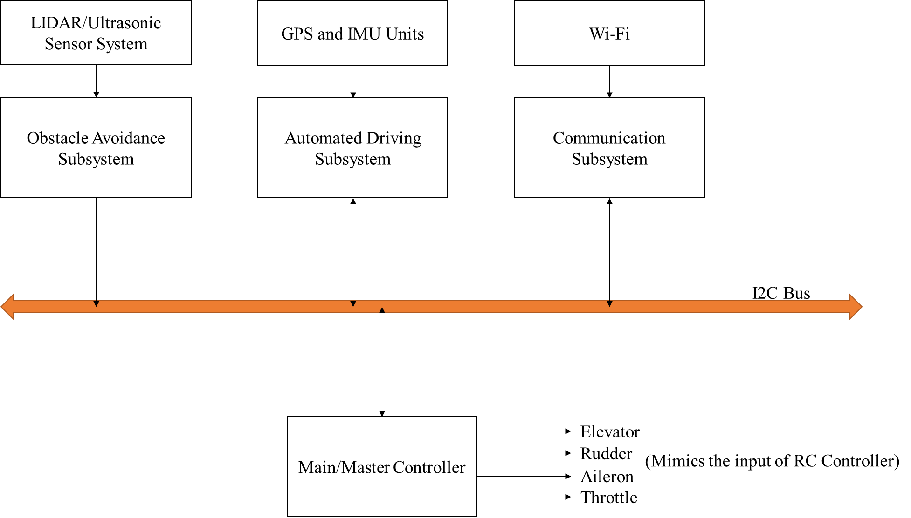

In this architecture, additional features can also be added since the communication bus is I2C and the master controller can be configured after adding the additional subsystems to the bus and integrated with the system easily. At the end, the Master controller combines all the inputs from multiple subsystems and takes decision based on its configuration input.

In our course project work, for this semester, we are planning to complete the Automated driving subsystem, communication subsystem and Master Controller.